ELECTRONIC VOTING SYSTEM

## A PROJECT REPORT

***Submitted by***

# MAILESHWARAN.P

# PREMNATH.S

# SELVA BALA ARUN.P

# RAHUL.R

***in partial fulfillment for the award of the degree of***

# BACHELOR OF TECHNOLOGY

**IN**

## PETROLEUM ENGINEERING AND TECHNOLOGY



**ALAGAPPA COLLEGE OF TECHNOLOGY, GUINDY**

# ANNA UNIVERSITY: CHENNAI 600 025

# OCTOBER 2023

**TABLE OF CONTENT**

|  |  |  |
| --- | --- | --- |
| **S.NO** | **TITLE** | **PAGE NO** |
|  | **LIST OF FIGURES** | **4** |
| **1.** | **INTRODUCTION**  1.1 Project Overview  1.2 Purpose | **5**  **5**  **5** |
| **2.** | **LITERATURE SURVEY**  2.1 Problem statement definition  2.2 References | **6**  **6**  **7** |
| **3.** | **IDEATION AND PROPOSED SOLUTION**  3.1 Empathy map  3.2 Ideation & Brainstorming | **8**  **8**  **9** |
| **4.** | **REQUIREMENT ANALYSIS**  4.1 Hardware Requirement  4.2 Software Requirement | **10**  **10**  **10** |
| **5.** | **PROJECT DESIGN**  5.1 Project Flow Diagram  5.2 Solution Architecture | **11**  **11**  **12** |
| **6.** | **CODING AND SOLUTION**  6.1 Coding  6.1.1 solidity coding in remix.etherium**-**  6.1.2solidity coding in visual studio  6.1.3 deployment of contract using remix | **12**  **12**  **12**  **13**  **13** |
| **7.** | **RESULT**  7.1 Output Screenshot | **14**  **14** |
| **8.** | **ADVANTAGES AND DISADVANTAGES**  8.1 Advantages  8.2 Disadvantages | **15**  **15**  **15** |
| **9.** | **CONCLUSION** | **15** |

**LIST OF FIGURES**

|  |  |
| --- | --- |
| **FIGURE** | **PAGE NO.** |
| **Figure 1 – Empathy map** | **8** |
| **Figure 2 – Ideation & Brainstroming** | **9** |
| **Figure 3 - voting system flow diagram** | **11** |
| **Figure 4 - solution architecture for the problem** | **12** |
| **Figure 5- Solidity code in Remix.Etherium** | **13** |
| **Figure 6 – solidity code in VS** | **13** |
| **Figure 7 - deploy of contract in remix.etherium** | **14** |
| **Figure 8 - frontend of the project** | **14** |

1. **INTRODUCTION**

Electoral integrity is essential not just for democratic nations but also for state voter’s trust and liability. Blockchain technology offers a decentralized node for online voting or electronic voting. Recently distributed ledger technologies such blockchain were used to produce electronic voting systems mainly because of their end-to-end verification advantages. Voting is a new phase of blockchain technology; in this area, the researchers are trying to leverage benefits such as transparency, secrecy, and non-repudiation that are essential for voting applications. With the usage of blockchain for electronic voting applications, efforts such as utilizing blockchain technology to secure and rectify elections have recently received much attention.

* 1. **PROJECT OVERVIEW**

**Electronic voting**, Form of computer-mediated voting in which voters make their selections with the aid of a computer. The voter usually chooses with the help of a touch-screen display, though audio interfaces can be made available for voters with visual disabilities. Blockchain technology are used to conduct E-Voting with the application of MetaMask, visual studio code(VS), Polygon Faucet, Remix Ethereum and node.js. The coding are done in vs code, Remix Ethereum and the final output are obtained in node.js.

* 1. **PURPOSE**

Electronic voting technology intends to speed the counting of ballots, reduce the cost of paying staff to count votes manually and can provide improved accessibility for disabled voters. A blockchain voting system is hugely beneficial because of its transparency, mathematically verified validity, and immutability of votes. Also, as with other online voting platforms, participants can cast votes at a time and place most convenient to them. Plus, end-users wouldn’t really notice a difference with a blockchain voting system on the frontend. However, the reputability, validity, and reliability of voting initiatives can be radically improved by implementing blockchain. So by the application of block chain technology we can improvise the Electronic voting system even further.

1. **LITERATURE SURVEY**
   1. **PROBLEM STATEMENT DEFINITION**

Voting is a method for a group of individuals to make a collective decision or voice their cumulative opinion to arrive at a consensus. The results of a vote can have far reaching consequences due to which it is imperative to maintain integrity by ensuring that there is no scope for fraud or cheating to occur while the votes are being cast. It is highly crucial that voting is carried out in a fair and just manner. This Electronic Voting System has been developed to help eliminate any chance of tampering and improve the reliability and dependability of a voting system. This system consists of two entities namely; The Admin and The Voter (The User). Once the Voter has logged in to the system using their valid username and password, they can view the upcoming elections and the candidates contesting the election. Users can also view results once the elections have concluded. This system also shows user the elections that they have participated in so far. On the other side of the application, the admin can view the list of candidates contesting, the list of voters, and the list of elections. Since this system maintains the data using blockchain, it is highly dependable and can be easily scanned to check for signs of tampering and malpractice.

* 1. **REFERENCES**

1. Paper by Ong Kang Yi and Debashish Das proposes an
2. Online Voting System that is Blockchain based to
3. uplift the integrity, making the voting process
4. optimized, producing voint results consistently, and
5. strengthening the transparency of the voting
6. system

|  |  |  |  |  |
| --- | --- | --- | --- | --- |
| **S.NO** | **AUTHOR** | **TITLE** | **YEAR** | **INFERENCE** |
| **1.** | Ben Ayed | Candidate-specific blockchains. | **2017** | Describes Estonia I-voting system and proposed a block chain based e-voting system with each block size, block header, transcation counter and transcation. |
| **2.** | Barnes et al. | Distributed Node Architecture. | **2017** | Consists of scalable architecture for large scale voting scenarios with national nodes managing constituency nodes. Two blockchains are used one for voter’s vote containing vote token prior to voting and other for voter’s vote. |
| **3.** | [Dhiraj Amrutkar](https://www.researchgate.net/scientific-contributions/Dhiraj-Amrutkar-2195454682?_tp=eyJjb250ZXh0Ijp7ImZpcnN0UGFnZSI6InB1YmxpY2F0aW9uIiwicGFnZSI6InB1YmxpY2F0aW9uIn19),  [Dhiraj Amrutkar](https://www.researchgate.net/scientific-contributions/Dhiraj-Amrutkar-2195454682),  [Gaurav Dongare](https://www.researchgate.net/scientific-contributions/Gaurav-Dongare-2195457515?_tp=eyJjb250ZXh0Ijp7ImZpcnN0UGFnZSI6InB1YmxpY2F0aW9uIiwicGFnZSI6InB1YmxpY2F0aW9uIn19),  [Sayog Sonune](https://www.researchgate.net/scientific-contributions/Sayog-Sonune-2195432053?_tp=eyJjb250ZXh0Ijp7ImZpcnN0UGFnZSI6InB1YmxpY2F0aW9uIiwicGFnZSI6InB1YmxpY2F0aW9uIn19),  [Dr-Archana Chaudhari](https://www.researchgate.net/profile/Dr-Archana-Chaudhari) | E-voting systems using blockchain: a systematic review and future research direction. | **2021** | In this paper, we call attention to the open research matters in this fast-growing field, explaining them in some details. It was concluded that frameworks needed enhancements in order to be used in voting systems due to these reservations. |
| **4.** | [UzmaJafar](https://pubmed.ncbi.nlm.nih.gov/?term=Jafar%20U%5BAuthor%5D), [MohdJuzaiddin AbAziz](https://pubmed.ncbi.nlm.nih.gov/?term=Aziz%20MJ%5BAuthor%5D), and [Zarina Shukur](https://pubmed.ncbi.nlm.nih.gov/?term=Shukur%20Z%5BAuthor%5D) | Block chain for Electronic Voting system- Review and open research Challenges. | **2021** | This study provides a conceptual description of the intended blockchain-based electronic voting application and an introduction to the fundamental structure and characteristics of the blockchain in connection to electronic voting. |
| **5.** | [Ritika Singh](https://www.researchgate.net/profile/Ritika-Singh-38?_tp=eyJjb250ZXh0Ijp7ImZpcnN0UGFnZSI6InB1YmxpY2F0aW9uIiwicGFnZSI6InB1YmxpY2F0aW9uIn19) | Electronic Voting System Using Blockchain | **2021** | This project appraises the competency of distributed ledgers technology through the explanation of a case study, namely the method of conducting an election and implementing a block chain based application which enhances the security of the system. |

**3. IDEATION AND PROPOSED SOLUTION**

**3.1** **EMPATHY MAP**

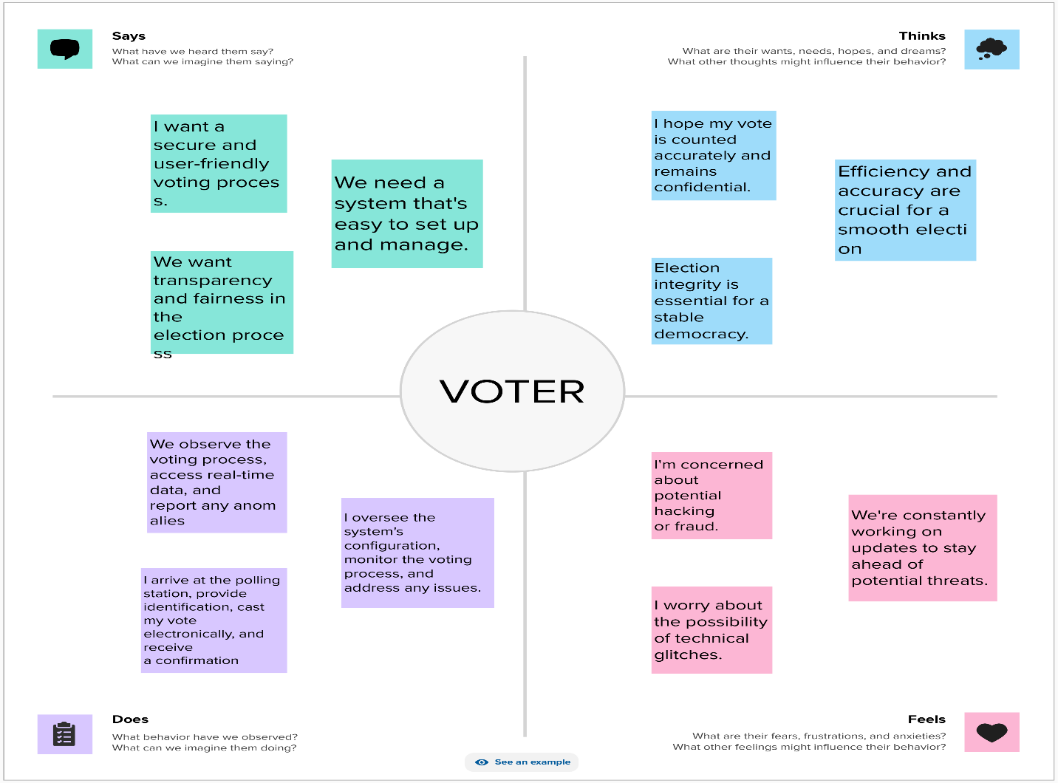

**Figure 1 – Emapthy map**

**3.2 IDEATION & BRAINSTORMING**

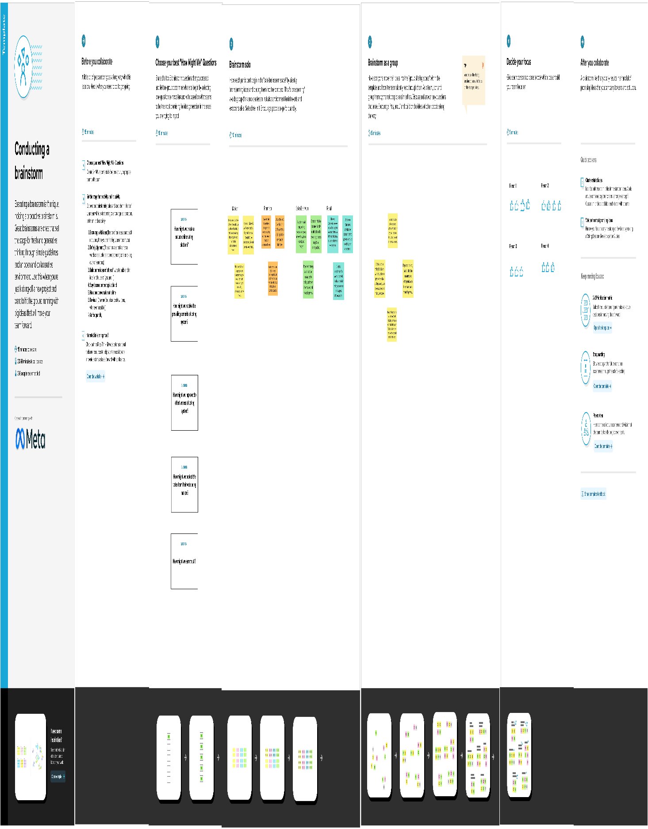

**Figure 2 – Ideation & Brainstorming**

**4. REQUIREMENT ANALYSIS**

**4.1 HARDWARE REQUIREMENT**

1. **Laptop or PC**

* Windows 7 or higher
* I3 processor system or higher
* 4 GB RAM or higher
* 100 GB ROM or higher

**4.2 SOFTWARE REQUIREMENT**

1. **Laptop or PC**

* Visual Studio 2019
* Mural
* Node,js
* MetaMask
* Remix.Ethereum
* Polygon faucet

**5. PROJECT DESIGN**

**5.1 PROJECT FLOW DIAGRAM**

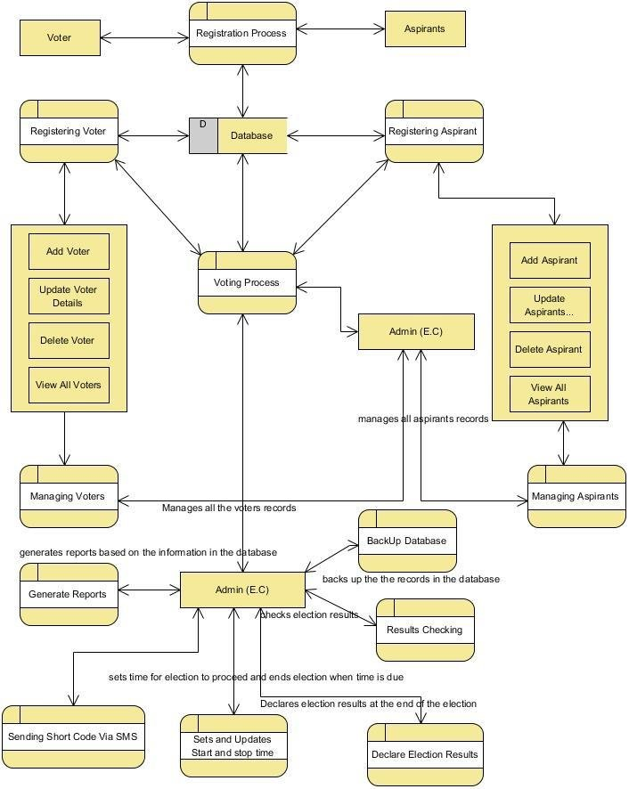

**Figure 3 – voting system flow diagram**

**5.2 SOLUTION ARCHITECTURE**

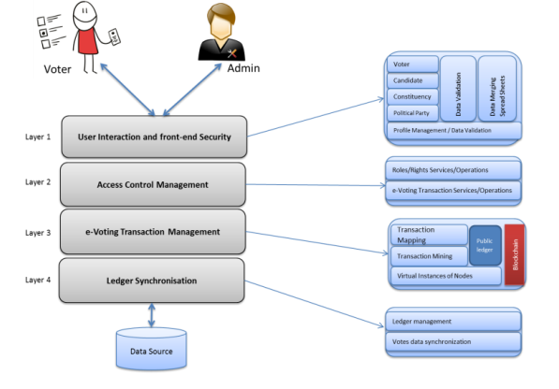

**Figure 4 – solution architecture for the problem**

**6. CODING AND SOLUTION**

**6.1 CODING**

**6.1.1 SOLIDITY CODING IN REMIX.ETHERIUM-**

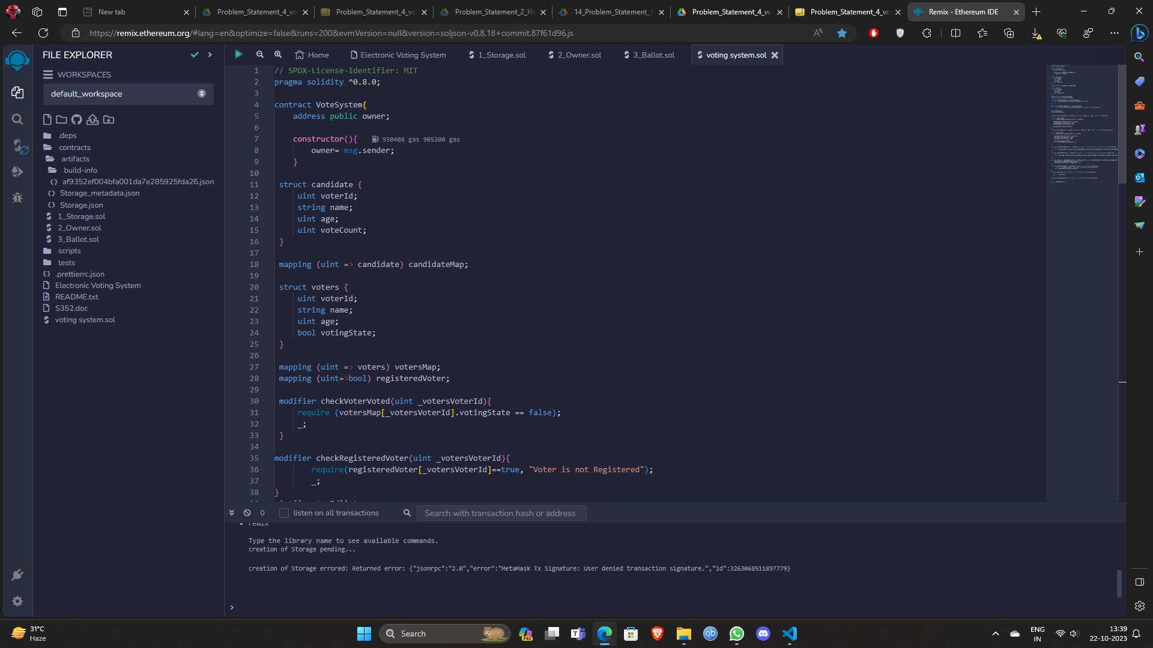

**Figure 5 – Solidity code in Remix.Etherium**

**6.1.2 SOLIDITY CODING IN VISUAL STUDIO-**

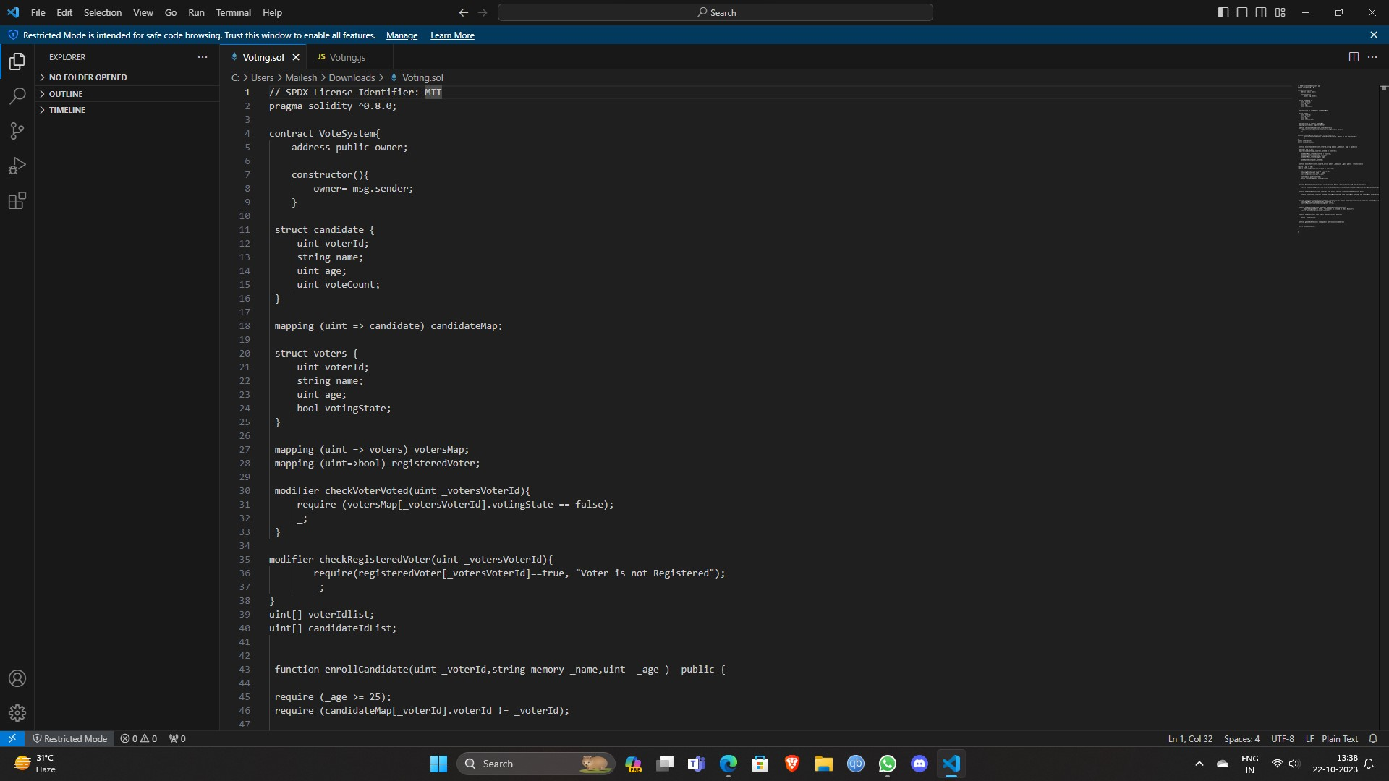

**Figure 6 – solidity code in VS**

**6.1.3** **DEPLOYMENT OF CONTRACT USING REMIX-**

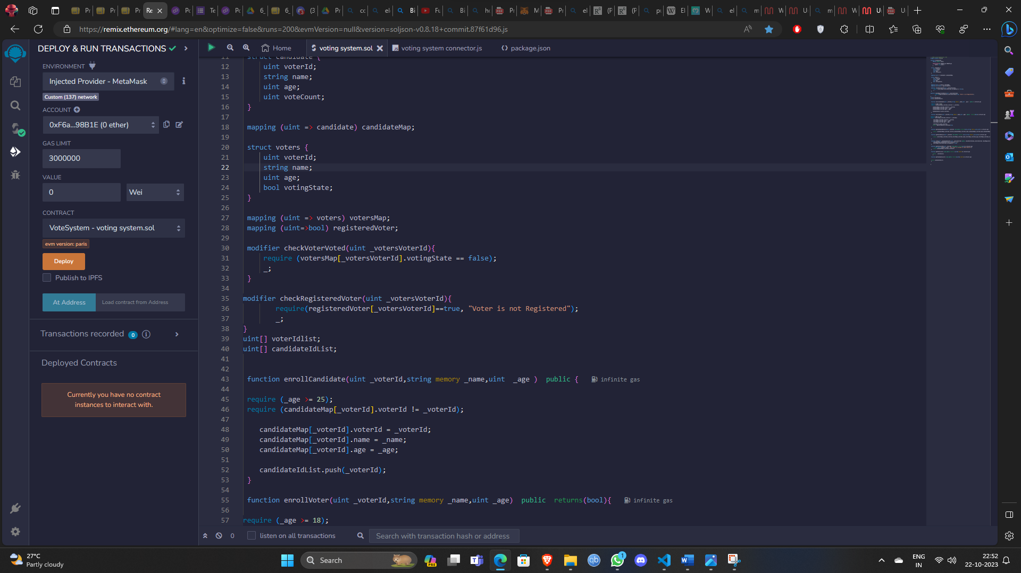

**Figure 7 -deploy of contract in remix.etherium**

**7. RESULT**

**7.1 OUTCOME OF THE PROJECT**

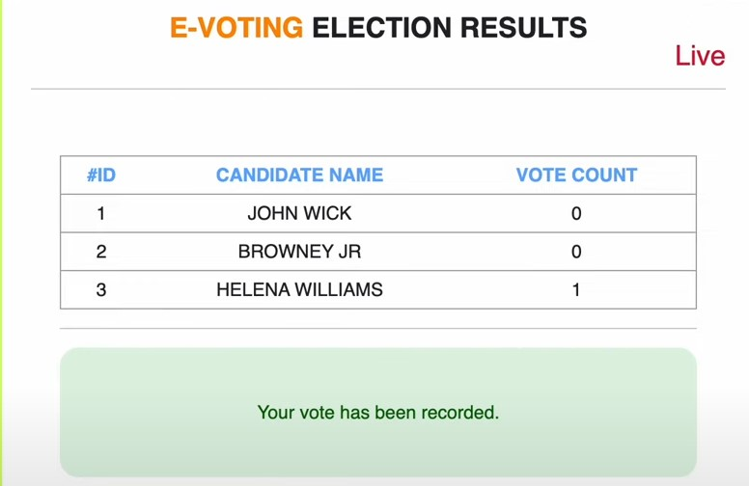

**Figure 8 -frontend of the project**

1. **ADVANTAGES & DISADVANTAGES**

**8.1 ADVANTAGES-**

* 1. User cannot know any information about the vote
  2. Votes cannot be tampered
  3. Blockchain is used for votes.

**8.2 DISADVANTAGES-**

1. Wrong inputs will affect the project outputs.
2. Internet Connection is mandatory
3. The android mobile user will not be able to insert or view details if the server goes down. Thus, there is disadvantage of single point failure.
4. Votes/Elections deleted cannot be restored
5. Not using any government id
6. Cannot register.
7. **CONCLUSION**

EVM’s are being used in India since years. Though the EVM technology proves more efficient than the ballot system, but the electronic voting will allow the users to caste their vote from their own devices and from the comfort of their home.[19] The use of block chain technology can provide mankind with the best solution to conduct elections in the most secure, transparent, flexible and cost-efficient way. The popularity of blockchain can easily be understood by the fact that this technology is being utilized by many crypto currencies, including bitcoin transaction framework.[20]The fact that, using this system, a user can cast his valuable vote from the comfort of his home by just making use of an electronic device will undoubtedly make sure that the election receives maximum vote input from eligible voters, and hence a majority of the population can decide whom they would like to elect as their leader and hence decide their fate.